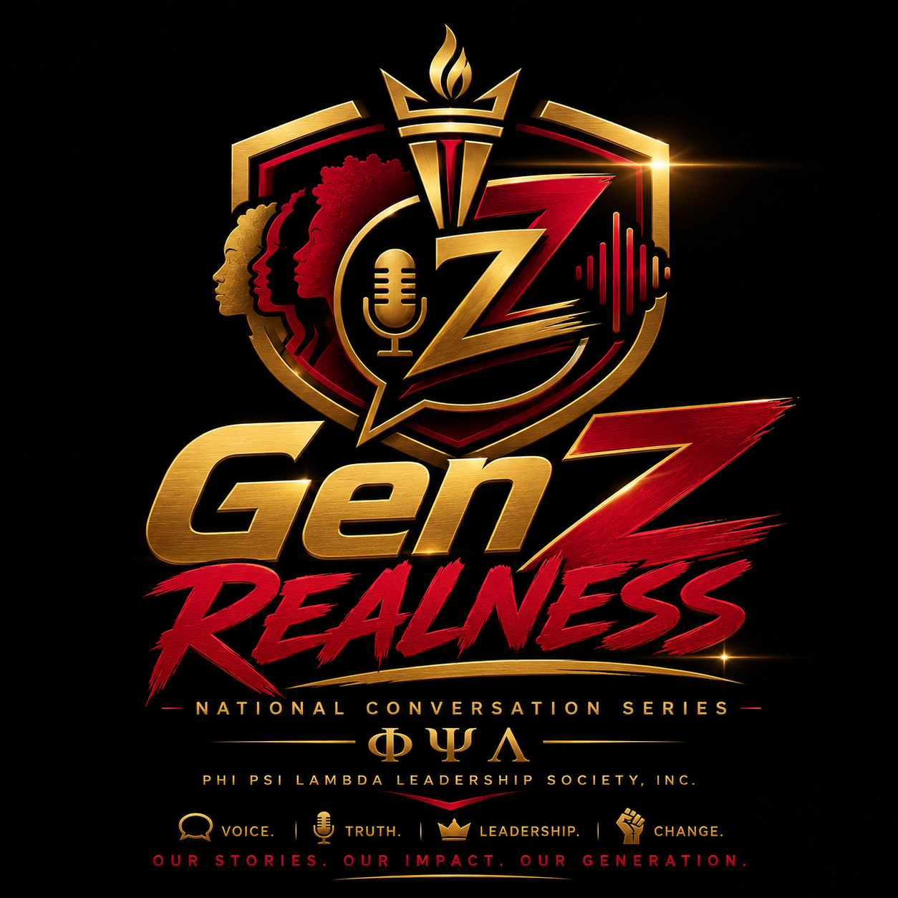
UNDER THREAT,
STILL RISING
HBCUs, Safety, and the Power of Collective Vision
National Program | GenZ Realness
Webinar Date | September 12, 2025
Presented By | Phi Psi Lambda Leadership Society, Inc.
Feature Focus | Black youth, HBCU safety, community power, and collective vision
Hosted by Joshua H. Jimenez, Alfred W. Lewis Jr., Kinde Mnkaptah, and Joel Lewis
Quotes are drawn from the provided webinar transcript and lightly edited for clarity.

UNDER THREAT, STILL RISING: HBCUS, SAFETY, AND THE POWER OF COLLECTIVE VISION
Inside Phi Psi Lambda Leadership Society, Inc.'s GenZ Realness webinar, Black students, young leaders, and community educators transformed fear into language, grief into strategy, and isolation into a renewed call for collective power.
Featured Article | GenZ Realness | September 12, 2025
WEBINAR HOSTS
Joshua H. Jimenez - International Senior Executive Vice President
Alfred W. Lewis Jr. - International Vice President of Media Relations and External Affairs
Kinde Mnkaptah - National Vice President of Cultural Affairs
Joel Lewis - National Vice President of Community and Public Relations

The Day the Campus Went Quiet
The first testimony arrived with the blunt clarity of a young man who had expected to spend his day as a student, not as a target. Joel Lewis, a second-year psychology major at Hampton University and National Vice President of Community and Public Relations for Phi Psi Lambda Leadership Society, Inc., had awakened that morning prepared for class. Then the email came: the campus was on lockdown. Classes were suspended. Students were told there was a proposed threat.
His first instinct was not political analysis. It was human. He sent the message to friends and family. He called his mother. He checked on classmates. Across campus, students were trading fragments of information, trying to separate rumor from reality while also trying to stay calm. Some had the option of driving home to family. Others did not. They remained in dorm rooms and residence halls, sheltering in place inside the institutions that had promised them intellectual freedom, cultural affirmation, and a life-changing education.
"I was scared," Lewis said. "I was wondering what is happening." Then, after a pause that carried more than one student's fear, he named the emotional weight of the moment: "It was just heavy."
That word - heavy - became the moral weather of the evening. It described the sudden pressure of being young and Black in America, the pressure of trying to build a future while history keeps announcing itself at the door. It described what it means for a campus to become still not because students are resting, but because they have been told danger may be near.
On September 12, 2025, Phi Psi Lambda Leadership Society, Inc. convened GenZ Realness for a webinar titled "Under Threat, Still Rising: HBCUs, Safety, and the Power of Collective Vision." The program was hosted by Joshua H. Jimenez, International Senior Executive Vice President; Alfred W. Lewis Jr., International Vice President of Media Relations and External Affairs; Kinde Mnkaptah, National Vice President of Cultural Affairs; and Joel Lewis, National Vice President of Community and Public Relations. Together, they did what Black institutions have always done in moments of danger: they made a room. They made language. They made witness. They made strategy.
This was not a panel staged for performance. It was a gathering called because students were frightened and because fear, when left alone, can become silence. Phi Psi Lambda refused that silence. GenZ Realness created a digital sanctuary where Black youth, men of color, students of HBCUs, and allies could speak without being reduced to headlines. They could be angry without being caricatured. They could be afraid without being dismissed. They could ask what safety means and then move, together, toward an answer.
"It was just heavy."
- Joel Lewis, Hampton University student and National VP of Community and Public Relations

A Safe Space Because No One Else Was Going to Build It
At the beginning of the webinar, Alfred Lewis Jr. set the tone with a truth that was both simple and searing. The space existed because it had to exist. "Who else is going to create this space for us?" he asked. It was not a rhetorical flourish. It was the central question of the night.
For generations, Black people in America have been forced to become architects of refuge. When public systems failed to protect them, they built churches, mutual aid societies, schools, newspapers, community centers, fraternities, sororities, and leadership organizations. Historically Black Colleges and Universities stand in that sacred tradition. They were never merely academic institutions. They were declarations that Black minds were not accidents, Black futures were not negotiable, and Black excellence did not require white permission.
That is why threats against HBCUs carry a significance far beyond campus logistics. A lockdown is not just a schedule disruption. A canceled class is not just an administrative update. For Black students, the threat is often felt as part of a longer pattern: Black progress is celebrated in public and punished in private; Black excellence is invited to perform and then warned not to gather too powerfully; Black youth are told to dream, then forced to calculate whether the place where they dream is safe.
The webinar insisted that those contradictions be named. Recent threats had forced various HBCU campuses across the United States to implement lockdowns and cancel classes. Speakers named the emotional rupture directly: students came to these campuses to pursue education, build friendships, experience Black joy, and prepare for leadership. They did not come to rehearse emergency protocols because someone else could not tolerate their existence.
Joel Lewis described safety as the right to do the ordinary things that make college life meaningful. "Safety for me is being able to do what I came here to do," he said, listing the simple rituals of student life: going to class, making connections, eating in the cafeteria, sitting in the library, walking with friends. When that safety is threatened, he said, "it feels like the rug is being pulled directly from under my feet."
There was power in that framing. Too often, conversations about campus safety become technical - doors, alerts, patrols, protocols. Those things matter. But for the students living inside the emergency, safety also means the ability to be young without fear. It means the ability to learn without looking over your shoulder. It means being able to belong to a place without wondering if that belonging makes you visible to violence.
"Safety for me is being able to do what I came here to do."
- Joel Lewis

The Black Community Knows the Cost of Being Targeted
The topic mattered because HBCUs sit at the intersection of education, memory, and liberation. They are among the most visible symbols of Black self-determination in the United States. To threaten them is to threaten more than buildings. It is to threaten a pipeline of teachers, physicians, engineers, artists, lawyers, organizers, scholars, business leaders, and public servants. It is to threaten the places where young Black people are not asked to shrink before they shine.
That is why the webinar moved quickly from personal fear to collective analysis. Participants understood that the danger was not random, even when the excuses appeared random. Brother Nas, a student participant, raised one of the night's most urgent questions: why are Black institutions so often targeted in moments of national outrage, even when they have no direct connection to the cause?
His answer went to the heart of the injustice. "They know the power of education," he said. "They would rather keep us docile and uninformed so they can control us easily."
Joshua Jimenez expanded on that point with the historical memory of a young leader who understands that the present is never disconnected from the past. He spoke of attacks on Black progress as part of a continuum that stretches from slavery to Jim Crow, from chain gangs to modern policies that limit access, power, and representation. The language of the moment may change, but the purpose remains familiar: disrupt Black advancement, then call the disruption normal.
"Education is essential," Jimenez said. "They always try to take away that power so communities cannot grow."
This is the injustice that Black youth are forced to inherit: they must prove their brilliance inside systems built to question it. They must pursue degrees while carrying the knowledge that their institutions are often underfunded, politicized, stereotyped, and endangered. They must celebrate homecoming while monitoring headlines. They must defend the legitimacy of HBCUs even as those institutions continue producing leaders across every sector of American life.
The featured conversation refused to treat Black fear as weakness. It treated fear as evidence. Evidence that the threats were real. Evidence that the stakes were high. Evidence that Black youth deserve more than sympathy after danger arrives. They deserve protection, investment, policy, infrastructure, and a national commitment to the safety of Black educational spaces.
"They know the power of education."
- Brother Nas, student participant

Against Individualism, Toward Interdependence
As the discussion deepened, it turned toward one of the most striking themes of the evening: the rejection of isolation. The panelists and participants challenged the idea that Black youth can survive the moment by simply focusing on individual success. They named individualism as a trap - one sharpened by a culture that tells young people to build a brand, chase the bag, and escape their communities rather than transform them.
Alfred Lewis Jr. drew a clean line between self-preservation and collective responsibility. "This is not the time to be in the middle," he said. "This is not the time to say, "I am not involved."" He invoked the spirit of Dr. Martin Luther King Jr.'s warning that injustice anywhere threatens justice everywhere, then pressed the point into the lives of the students listening: what happens to your brother is happening to you, even if it has not reached your doorstep yet.
The critique of individualism became a critique of capitalism and the culture it produces. Participants spoke about a society that trains people to compete for status while neglecting the well-being of the person beside them. Kinde Mnkaptah imagined a different moral economy - one where knowledge is shared freely, human beings honor the person next to them, and money is not allowed to become the barrier that prevents care.
"Money should not be a limiter to anyone's potential to help another human being," Mnkaptah said.
Jimenez challenged listeners to think about consumption and complicity. He named the constant chase for the newest phone, newest car, and newest symbol of status as a cultural distraction from community investment. He did not present the solution as perfection. He presented it as consciousness. "If we start thinking together," he said, "those are the first steps."
Lewis Jr. sharpened the call further, urging young Black people to join something bigger than themselves - a Black Student Union, a community organization, a campus movement, a leadership society, a coalition that could convert concern into action. "Society did not get here by being self-dependent," he said. "Society got here by being interdependent."
That word, interdependent, was one of the most important words of the webinar. It captured the political, spiritual, and generational assignment of the night. Interdependence does not mean losing oneself in the crowd. It means understanding that the crowd is part of the self. It means the engineer needs the organizer, the artist needs the educator, the student needs the elder, the campus needs the community, and the future needs all of them moving in relationship.
"Society did not get here by being self-dependent. Society got here by being interdependent."
- Alfred W. Lewis Jr.

What Gen Z Needed Was Not a Lecture. It Needed a Platform.
The genius of GenZ Realness is that it does not mistake young people for an audience waiting to be instructed. It treats them as thinkers, witnesses, strategists, and builders. In this webinar, young Black voices were not decorative. They were central. They shaped the questions, complicated the answers, and pushed the conversation beyond comfort.
When Brother Nas asked how communities should navigate a hostile national environment, he did not ask as a spectator. He asked as someone reading the temperature of the country and trying to understand how Black youth can move through it without becoming numb. He noted that people often choose when to express outrage and when to withhold it, and he questioned a public morality that seems inconsistent when Black women, Black men, and Black institutions are harmed.
Jimenez answered by pointing to information as a form of protection. "A lot of the tensions and the discourse is caused because of the lack of information," he said. Misinformation and disinformation, he argued, create emotional reactions that can be weaponized. The response, then, must be education, research, empathy, and courageous conversations - not only with those who agree, but also with those who do not.
Mnkaptah added that surface-level media consumption would not carry the community forward. "A lot of the times people will see the Instagram reel, but they will not dig any further," he said. "That is not how we are going to get through it."
That exchange revealed why Phi Psi Lambda's work matters. GenZ Realness is not simply a webinar series. It is a counter-platform in a media environment that often rewards outrage over understanding. It gives young people the chance to slow down, verify, question, grieve, analyze, and organize. It treats dialogue as discipline and listening as leadership.
For Gen Z and millennials, that matters. These generations have inherited economic instability, racial backlash, political extremism, climate anxiety, online misinformation, and the constant pressure to turn pain into content. They do not need another institution telling them to be resilient while leaving them alone in the storm. They need rooms where resilience is shared, where strategy is built, and where leadership is practiced in real time.
Phi Psi Lambda provided that room.

The Power of Small Groups With a Clear Vision
One of the evening's most moving interventions came from an educator who joined the conversation and offered an outside affirmation of what was happening in the room. She said that small groups are incredibly powerful and told the young men that what they had built was valuable, important, and potentially transformative. She did not romanticize the political climate. She named the danger. But she also recognized the rare force of a network of young men of color speaking with compassion, clarity, and readiness.
Her question was the question behind every movement: now what?
Jimenez answered with one of Phi Psi Lambda's central organizing principles: vision. "Vision guides movement," he said. "It inspires people. It can galvanize people because they understand where they are heading." The absence of vision, he argued, leaves a generation struggling to understand not only the present crisis, but the next five years, the next ten years, the next version of America.
Lewis Jr. connected that principle directly to the organization's mission. Phi Psi Lambda, he reminded attendees, is grounded in the inspiration and cultivation of leadership among men of color universally. It exists because someone first had a vision that young men of color deserved an institution where their leadership could be named, trained, affirmed, and mobilized.
"Before we say what do we do, let's ask what do we want," Lewis Jr. said. "Once we do that, come together as a coalition, continue to do the work that we are already doing, and work with each other to form this common goal, then our vision can become more clear."
That answer was not abstract. It was a strategic framework. A community under threat needs more than reaction. It needs a shared destination. It needs to know what safety looks like, what education should guarantee, what leadership must demand, and what Black youth are owed. It needs to build coalitions across campuses, cities, chapters, families, and generations. It needs a language that can survive the news cycle and become a plan.
The webinar did not pretend that a single conversation could solve violence, racism, underfunding, or the politics of fear. But it did show what happens when young leaders refuse to meet crisis with confusion alone. They gathered. They listened. They studied. They challenged one another. They asked what systems had to change, and they asked what they had to become in order to change them.
"Vision guides movement. It can galvanize people because they understand where they are heading."
- Joshua H. Jimenez

Still Rising
By the end of the evening, the fear that opened the webinar had not disappeared. That would have been dishonest. Students still had to monitor campus updates. HBCU communities still had to remain alert. The nation was still tense. The systems being challenged were still powerful. But something had shifted. The fear was no longer solitary.
Latif Bwire, a student from North Carolina A&T State University, gave language to the shared pain and the shared assignment. "We should never have to feel scared," he said. "It is really detrimental that we stay as a community together and use the voices that we have to branch out and speak on what we feel is right."
Mnkaptah closed with a message that sounded like both comfort and command. "Do not let any of this fear paralyze you," he said. "Use those around you to keep moving."
Jimenez urged attendees to follow passion and purpose rather than surrendering their lives to what others expect of them. "Life will be so much more fulfilling if you follow your passion," he said. Purpose, in his framing, was not merely personal. It was contagious. It would seep into relationships, collectives, and the work of building something larger than the self.
Joel Lewis ended where he began - with the campus, with students, with the practical need to stay informed and safe. At Hampton, he said, there was a phased return plan. Classes would resume. Students would go back. That return mattered. Every time Black students walk back into classrooms after fear tries to empty them, they enact a quiet form of resistance. They return because the education is worth defending. They return because their ancestors were denied what they now pursue. They return because the future still has their name on it.
"Under Threat, Still Rising" was more than a title. It was a diagnosis and a declaration. Under threat names the world as it is: Black institutions targeted, Black students burdened, Black communities asked again to absorb the shock. Still rising names the world Black youth are building anyway: informed, connected, interdependent, visionary, and unwilling to abandon one another.
The Black community does not need young people to become invincible. It needs them to become organized. It needs them to become informed. It needs them to become honest enough to name fear and brave enough not to let fear lead. It needs institutions like Phi Psi Lambda Leadership Society, Inc. that understand leadership is not a title pinned to a blazer. It is a responsibility carried into rooms where people are hurting and a commitment to leave those rooms with more courage than when they entered.
On September 12, 2025, GenZ Realness became that kind of room. It became a place where Black youth could say they were scared and still sound powerful. A place where students could talk about lockdowns and still imagine liberation. A place where the sons of HBCUs, the brothers of Phi Psi Lambda, and the communities that love them could remember that safety is not a favor. It is a right. Education is not a privilege to be threatened. It is a birthright to be protected. And collective vision is not a slogan. It is how a people survives the storm and rises with its future still intact.
"Do not let any of this fear paralyze you. Use those around you to keep moving."
- Kinde Mnkaptah

About GenZ Realness
GenZ Realness is a national program of Phi Psi Lambda Leadership Society, Inc. designed to center the voices, questions, leadership, and lived experiences of Generation Z. Through courageous dialogue, cultural analysis, and community-centered reflection, the program creates a platform where young leaders can speak with clarity, build with purpose, and imagine a future rooted in justice, education, brotherhood, activism, and collective power.
This feature article was prepared from the webinar summary and transcript provided for "Under Threat, Still Rising: HBCUs, Safety, and the Power of Collective Vision." It honors the young leaders, students, and community voices who entered the conversation with honesty and left it with a stronger vision for what Black youth and Black institutions deserve.

